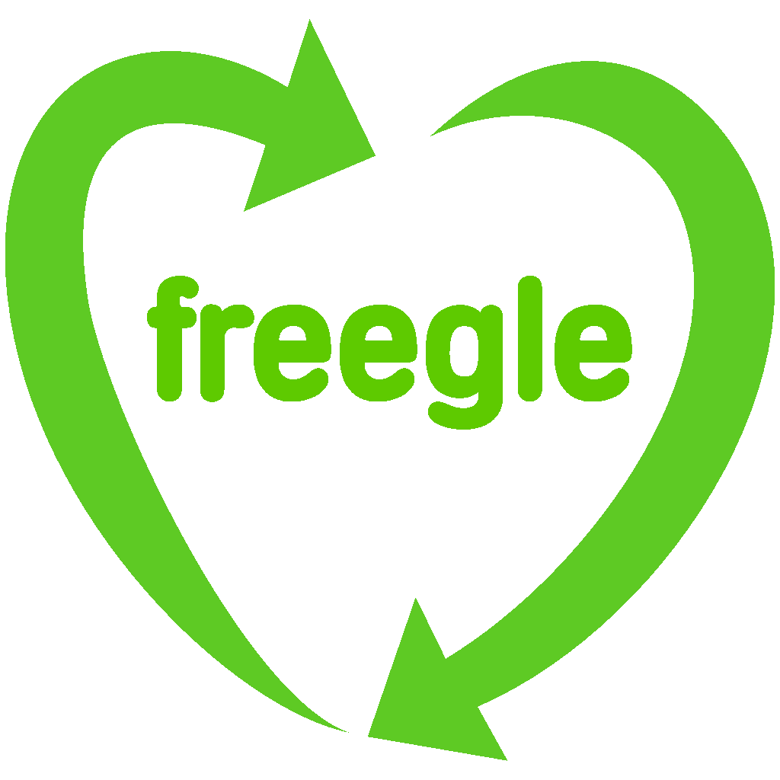
Penrith and Eden District Freegle
www.ilovefreegle.org
www.penrithedenfreegle.org.uk

Group volunteers:
Chris Cant, Elaine Bones, Juliet Gray, Judith-Ann Wardlaw

Chris Cant, Lake View, Bampton, Penrith CA10 2QU
01931 713240, chris@phdcc.com

Press Release for Immediate Release 21 September 2016

Freegle Give and Take in Shap, on Saturday 1st October 2016
Grab yourself a freebie on Saturday 1st October at the Freegle Give and Take at the Old Courthouse in Shap from 10am to 2pm.
It’s like a jumble sale, but free. Bring along stuff to give away if you can! And come along to pick up something for nothing!.
Freegle organiser Chris Cant says, “This will be our third Give and Take at Shap and we're really pleased to be back to help people hand on items to each other. Previously everything from plants and garden spades to books and clothes were handed on. We are really pleased to have support from the Cumbria Waste Prevention Fund to put on this event.”
Cumbria County Council Waste Prevention Officer Judith Bradshaw said, “This is a fantastic event, which is about more than just giving away goods. Reusing a 'pre-loved' item means that you don't need to buy as much which can offer a saving for you and also a reduction in the carbon emissions that would be required to manufacture and transport that item if you were to buy it brand new. Also by extending that item's life we can reduce waste treatment costs".
Anything left over will either be Freegled or given away to a charity shop to sell. Teas and coffees available for 50p.
For more info see http://www.penrithedenfreegle.org.uk/events/shap-give-take-oct-2016

NOTES TO EDITORS

- It is estimated that locally our group saves up to 6 tonnes from landfill each month
- For further information about the local Freegle group please contact Chris Cant 01931 713240 or Elaine Bones 016974 75398.
- Freegle’s objective is to enable individuals to ‘do their bit’ by stopping reusable items going to waste by giving away things they don’t want to people who can use them. This is truly grass-roots and co-operatively run by and for local people.
- Freegle is hosted by the free service available at www.ilovefreegle.org
- Once a member of Freegle, you can send a message to the group offering an item for free, saying what it is and where you are. You can also ask for items that you want.

